AS Path

🌐 What Is AS Path?
# Source: Chatgpt (GPT‑5 Mini) at [12/15/2025]
An AS path (Autonomous System path) is a list of ASNs (Autonomous System Numbers) that a BGP route advertisement has passed through. It is used by Border Gateway Protocol (BGP) to determine the best path to reach a destination on the internet.

🧠 Simple Definition:
# Source: Chatgpt (GPT‑5 Mini) at [12/15/2025]
The AS path shows the sequence of networks (ASes) that data must travel through to reach a specific IP prefix. BGP routers use this list to make routing decisions.

📦 Example of an AS Path:
# Source: Chatgpt (GPT‑5 Mini) at [12/15/2025]
Suppose a router receives a BGP update like:
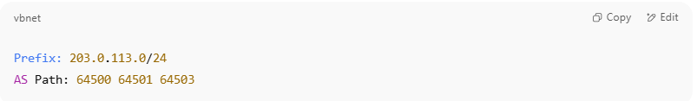
Prefix: 203.0.113.0/24
AS Path: 64500 64501 64503

This means:
- The route originated from AS 64503
- It passed through AS 64501
- Then passed through AS 64500
- Now it's received by your router

🧭 How AS Path Works in BGP
# Source: Chatgpt (GPT‑5 Mini) at [12/15/2025]
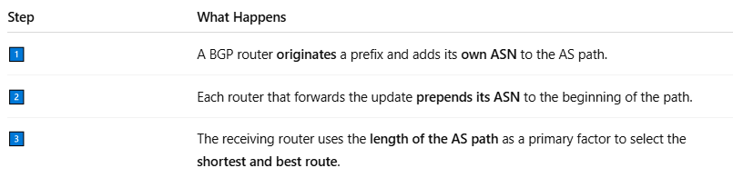

Step | What Happens
1️⃣ | A BGP router originates a prefix and adds its own ASN to the AS path.
2️⃣ | Each router that forwards the update prepends its ASN to the beginning of the path.
3️⃣ | The receiving router uses the length of the AS path as a primary factor to select the shortest and best route.

📏 AS Path Length
# Source: Chatgpt (GPT‑5 Mini) at [12/15/2025]
- BGP prefers the shortest AS path to reduce the number of AS hops.
- Example:
  - AS Path 1: 64510 64520 64530 (3 hops)
  - AS Path 2: 64540 64530 (2 hops) → BGP prefers this one

🚧 AS Path Filtering
# Source: Chatgpt (GPT‑5 Mini) at [12/15/2025]
BGP can filter or prefer certain routes based on:
- Specific ASNs (block or allow)
- AS path length (avoid long paths)
- Regular expressions (to match AS path patterns)

🔄 AS Path Prepending
# Source: Chatgpt (GPT‑5 Mini) at [12/15/2025]
AS path prepending is a technique used to artificially lengthen an AS path to make it less preferred.
Example:
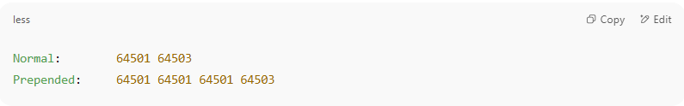
Normal: 64501 64503
Prepended: 64501 64501 64501 64503

→ Makes the path look "longer" and less attractive to others.

✅ Summary
# Source: Chatgpt (GPT‑5 Mini) at [12/15/2025]
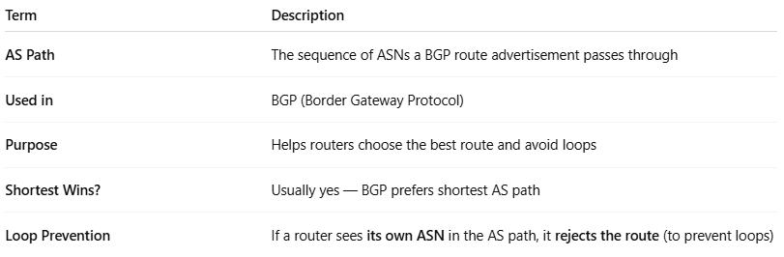

Term | Description
AS Path | The sequence of ASNs a BGP route advertisement passes through
Used in | BGP (Border Gateway Protocol)
Purpose | Helps routers choose the best route and avoid loops
Shortest Wins? | Usually yes — BGP prefers shortest AS path
Loop Prevention | If a router sees its own ASN in the AS path, it rejects the route (to prevent loops)

